

Tech Shastra Pvt. Ltd. Reg No: 189113/74/075
Thapathali, Kathmandu VAT No: 606714581
9851133302
Date: 11 December, 2023
TO WHOM IT MAY CONCERN
This is to certify that Mr. Aditya Sharma son of Mr. Diwakar Sharma and permanent resident of Nepalgunj-1, Banke was associated with this organization from 6 April, 2020 to 31 November, 2023 with our entire satisfaction as an IT Officer.
On his work, we found him a sincere, honest hardworking, dedicated employee with a professional attitude and very good knowledge. He is amiable in nature and character as is well.
We have no objection to allow him in any better position and have no liabilities in our company.
We wish him every success in life.
Best Regards,
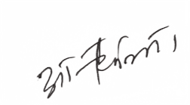
Aashish Thapaliya
Managing Director

